LAB REPORT

(Names) Bryon Ferrer, Sajana Wijesinghe
(Date) 10/25/18

Title: Lab Number 6
Statement of the Problem:

The question we are trying to answer in this lab session is “How can we use Arduino software to detect signals gained from the hardware?” The hardware in this case relates to passive sensors, which can detect any physical event and provide info that can be used for action or reaction. Passive sensors have an advantage in this case over active sensors because passive sensors do not send out a physical signal and read back the reaction to that signal. Physical sensors can also be detected by other forces, which is why they are particularly disadvantageous when used in wartime. However, in this lab, we are using a photosensitive resistor, or PSR, with a resistance value depending on the amount of light that strikes it’s surface. When connected with a standard fixed resistor between the voltage source and the ground, the current flow and voltage across the resistor changes the level of light. This can allow the Arduino program to detect light level based on the input gained from the joining of the PSR and the fixed resistor.

Materials:
- USB Cable
- Arduino Uno microprocessor
- CdS PhotoSensitive Resistor(s)
- 10K Ohm Resistor
- Parallax PIR Motion Sensor

Procedure:

So, we start off by setting up our components together as shown in the picture below.

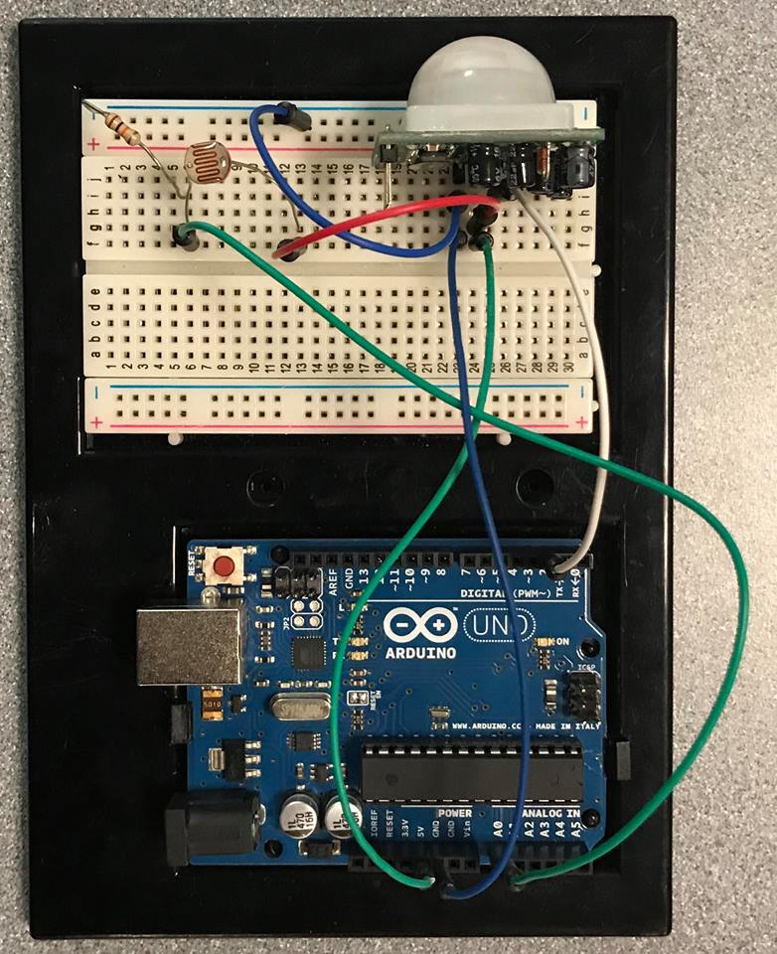

Once this is set up, the motion sensor should turn on immediately. You’ll be able to tell it on when you see the red light that appear on in whenever there is any type of motion near it. In order to know the light intensity detected by the light sensor, you’ll have to type the following code into the Arduino.exe program.

Results:
const int psrPin = 0; //Analog pin for CdS Photoresistor
const int pirPin = 2; //Pin for input from PIR Sensor
const int ledPin = 13; //Pin for output LED

void setup() {
Serial.begin(9600);
pinMode(ledPin, OUTPUT); // Output for LED
pinMode(pirPin, INPUT); // Input for PIR Sensor
}

void loop() {
int rate = analogRead(psrPin); // Read the value of the light level
Serial.print(rate); //Print its value
for (int i =0; i < rate / 30; i++) // and print a bar graph
Serial.print("*");
Serial.print("\n");
delay(1000); // Delay for a second
int val = digitalRead(pirPin); // Read PIR Sensor
if (val == HIGH)
digitalWrite(ledPin, HIGH);
else
digitalWrite(ledPin, LOW);
}

Once you are done typing it down. Compile and run it. Then open the serial monitor to see the output of the light senor. The output on the serial monitor should look something like the image below.

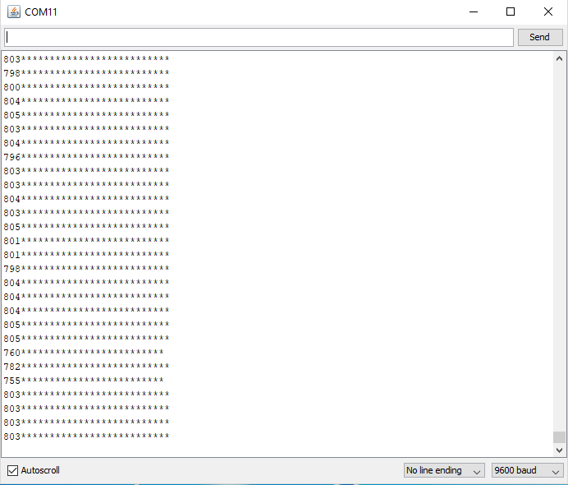

Depending on the light intensity the values will go up and down. Essentially if you cover the light sensor with your hands, the values will go down and the opposite happens when you shine some light on it.

Conclusions:

There are a couple of things I learned from the lab. First, I learned about interfacing hardware to a microprocessor and its software by using analogRead and getting data using pinMode and using digitalWrite to get the output for the LED on the microprocessor and Serial.print to get the output for the sensor. Second, I learned more about passive sensors and how they’re different from active sensors and how both can be useful in different situations. Third, I learned more about photosensitive sensors and how they can be combined with normal resistors to get the input for the Arduino program to use that data for it’s output. There are a couple of experimental errors, from making the wrong circuits with the wires to using the wrong kind of resistors and putting them in different places of the cycle. Other than that, it was interesting what outputs the program can get from other distances and angles from the sensors.

